Alg 3 Name: ____________________________

______________ _____________

WS Assessment

Target 7:

Parabola function and piecewise graph

**I can:**

* Write / convert parabola functions in standard - vertex – and factor form
* Graph Step and Piecewise Functions - with understanding domain and range
* **Unit 3: Function and Their Inverse**
* **CCSS.Math.Content.HSF.BF.B.4**: Find inverse functions
* **CCSS.Math.Content.HSF.BF.B.4.A**: Solve an equation of the form f(x) = C for a simple function f that has an inverse and write an expression for the inverse.

 For example, f(x) =2 x3 or f(x) = (x+1)/(x-1) for x ≠ 1

* **CCSS.Math.Content.HSF.IF.B.5**: Relate the domain of a function to its graph and, where applicable, to the quantitative relationship it describes. For example, if the function h(n) gives the number of person-hours it takes to assemble n engines in a factory, then the positive integers would be an appropriate domain for the function.*
* **CCSS.Math.Content.HSF.BF.A.1**: Write a function that describes a relationship between two quantities
* [**CCSS.MATH.CONTENT.HSF.IF.C.7.B**](http://www.corestandards.org/Math/Content/HSF/IF/C/7/b/)**:** Graph square root, cube root, and piecewise-defined functions, including step functions and absolute value functions

HW#7 Piecewise function – [www.deltamath.com](http://www.deltamath.com)

Parabola's forms: There are three form of parabola:

1. Standard form y = ax2 + bx + c Useful if applying the formula you nothing

2. Vertex form y = a(x – h)2 + k Show the vertex (h, k) maximum/minimum

3. Root form y = a(x – x1)(x – x2) Show the roots (the solution)

The task is converting from one form of the parabola to other form.

***Convert from standard y = ax2 + bx + c to vertex y = a(x – h)2 + k***

Method 1: Complete the square Method 2: Using vertex formula

$h=\frac{-b}{2a}$ $k=c-\frac{b^{2}}{4a}$

Convert y = x2 + 6x + 10 to vertex form

Method 1 y = x2 + 6x + 8 y = x2 + 10x + 27

Method 2 y = 2x2 + 4x + 6 y = 3x2 + 6x + 8

***Convert from vertex y = a(x – h)2 + k to standard y = ax2 + bx + c***

Convert y = 2(x – 3)2 + 4 to standard form

y = 2(x + 4)2 – 20 y = 2(x + 3)2 + 2

y = 3(x – 4)2 + 1 y = (x – 5)2 + 3

***Convert from standard y = ax2 + bx + c to factor form y = a(x – root1)(x – root2)***

Convert y = 2x2 + x – 6 to root form (find roots)

y = 4x2 + 3x – 1 y = 10x2 + 35x – 20

y = x2 + 3x – 28 y = x2 – 2x – 35

***Convert from factor form y = a(x – root1)(x – root2) to standard y = ax2 + bx + c***

Convert y = 2(x – 3) (x + 1) to standard

y = 4(x + 2)(x – 3) y = (x – 5)(x – 8)

Piecewise Function: A piecewise function is a function in which more than one formula is used to define the output over different pieces of the **domain**.

1. Sketch a graph of the following

y = x + 2 y = (x – 1)2

2. Now graph the following and find the value of the given

$y=\left\{\begin{matrix}-3; -5≤ x<1 \\ -x^{2}+4 ; x≥1\end{matrix}\right\}$ $f(x)=\left\{\begin{matrix}{2x}^{2}-1; x<1 \\ x+4 ; 1≤x≤51\end{matrix}\right\}$

Find y(-2) = _____ and y(2) = _____ Find f(-2) = _____ and f(2) = _____

Write the piecewise functions and show me the following graphs on calculator or desmos for stamp

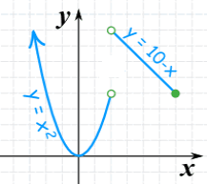 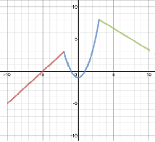

Step Function: A step function is a piecewise function whose parts are constant functions, or horizontal lines. Write the piece wise (step) function for the following graph and show me for stamp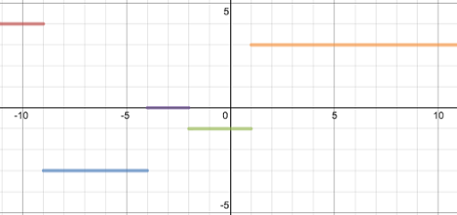

Write the piecewise functions for this graph (feel free to check it). At least 10 equations. Extra is extra credit. Show me for stamp

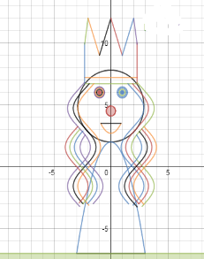

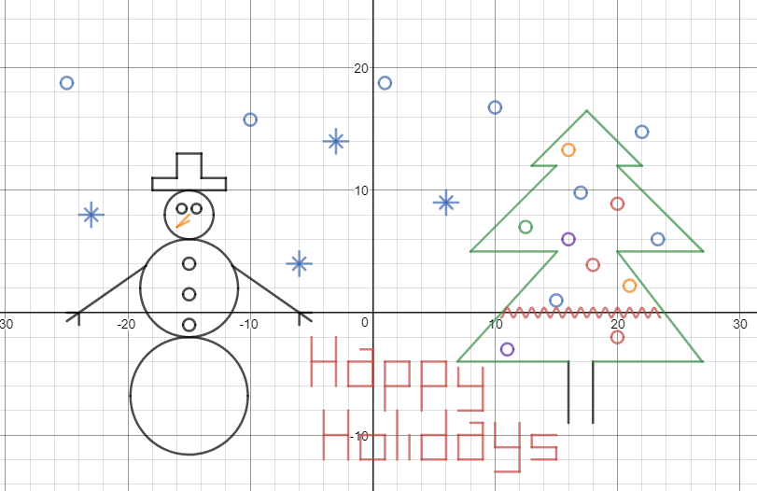

**Assessment Target 7**

**I can…** convert between the parabola form and do piecewise functions

1. Let a = ___ b = ____ c = -_____ .

The standard form of the quadratic y = ax2 + bx + c is ___________________________

Convert this into vertex form.

2. Let a = _____ h = ____ k = - _____

The vertex form of quadratic y = a(x – h)2 + k is ___________________________

Convert this into standard form

3. Given the parabola that has roots at – 2 and 3 and y-intercept (0, -12).

Write the equation of this parabola in three forms: standard, vertex and factor

4. Show me the following piecewise graph for stamps

